

World Elevator & Escalator Expo Organizing Committee

Tel：(86)18031689525/18630608890 Booth Application：

(86)316-6078901/6078902/6078325 Booth area：

E-mail：[data@elevator-expo.com](mailto:data@elevator-expo.com) ㎡

Web：[www.elevator-expo.com](https://www.elevator-expo.com)

Basic information of the registered unit

|  |  |  |  |  |  |  |
| --- | --- | --- | --- | --- | --- | --- |
| Company Information Exhibition Registration Form | | | | | | |
| Company Name |  | | | | | |
| Contact Address |  | | | | | |
| Country |  | | City |  | Tel | 1. 2. |
| Fax |  | | | | E-mail |  |
| Web |  | | | | Headquarters |  |
| Exhibition  Contact | Name |  | | | Title |  |
| Tel |  | | | Fax |  |
| Mobile |  | | | E-mail |  |

Booth type and price

|  |  |
| --- | --- |
| Type | Price |
| Raw Space | 220$ /㎡/exhibition period, minimum order of 48㎡ |
| Standard booth | 12 square meters per unit, 300$ per unit per exhibition period |

Standard booth configuration description

（1）Area: 12 square meters (3 meters * 4 meters), height 2.5 meters

（2）Booth panels: white standard frame, 3-sided panels (for double-sided booths, there are 2-sided panels)

（3）Nameplate (Chinese and English name, booth number) - 1 piece (2 nameplates for double-sided booths)

（4）Consultation desk - 1 piece

（5）Meeting chairs - 2 pieces

（6）Short spotlight (100w) - 2 pieces

（7）Power socket (220v/5A) - 1 unit

（8）Trash can - 1 unit

（9）Carpet - 12 square meters

Appendix: Standard Booth Configuration

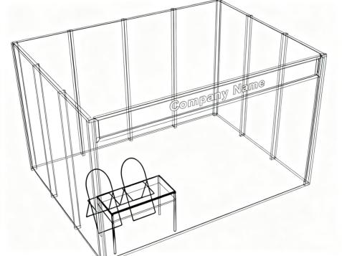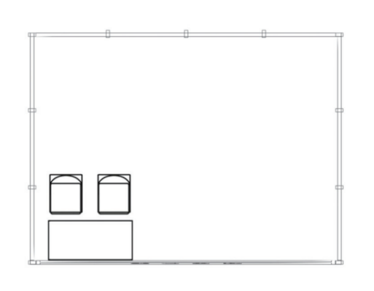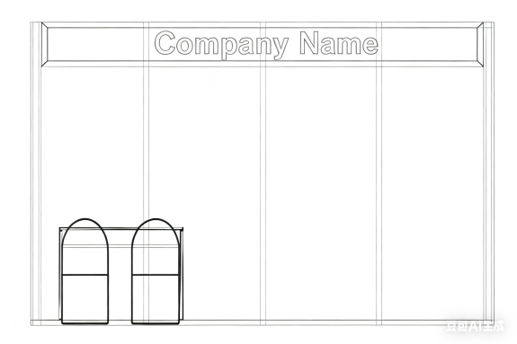

Note: According to the exhibition requirements, if the booth needs to be adjusted, it will be based on the actual

situation, and adjustments will be made by the organizing committee.

Product list

Complete machine

🞎 Passenger elevator 🞎 Villa elevator 🞎 Special elevator

🞎 Sightseeing elevator 🞎 Medical elevator 🞎 Moving walkway

🞎 Freight elevator 🞎 Vehicle elevator 🞎 Mine elevator

🞎 Escalator 🞎 Cargo elevator 🞎 Related industries

Acessory

🞎 Towing drive system 🞎 Guide rail system 🞎 Elevator car

🞎 door system 🞎 Weight balancing system 🞎 Electrical control system

🞎 Elevator decoration 🞎 Security and the Internet of Things 🞎 hydraulic system

🞎 Protective equipment 🞎 Escalator accessories 🞎 Small accessories

🞎 Other components 🞎 Safety protection system

Parking exhibition area

🞎 Smart parking equipment 🞎 Mechanical parking area 🞎 Intelligent Parking Management System

🞎 Intelligent Parking Charging System 🞎 Intelligent parking assist product 🞎 3D Parking Management System

🞎 Parking lot related facilities 🞎 Parking accessories

🞎 New energy vehicle charging and swapping system 🞎 Parking Security Series

The exhibiting unit confirms its participation. Please stamp this registration form and send a scanned copy to the Organizing Committee

of the World Elevator&Escalator Expo (Langfang Conference & Exhibition Co., Ltd.), so that the exhibition application can take effect.

World Elevator & Escalator Expo Organizing Committee

Add：No. 2 Guangyang East Road, Guangyang District, Langfang City, Hebei Province

Contact person：Ma Zhentao

Remittance unit: Langfang Conference and Exhibition Co., Ltd. Stamp:

Account number：1001 4858 3187

Bank of Account: Bank of China Langfang Development Zone Branch Sign:

Tel：400 612 5855

+86 316 6078901 6078902 6078325 Date:

Fax：+86 316 6078903

E-mail：data@elevator-expo.com